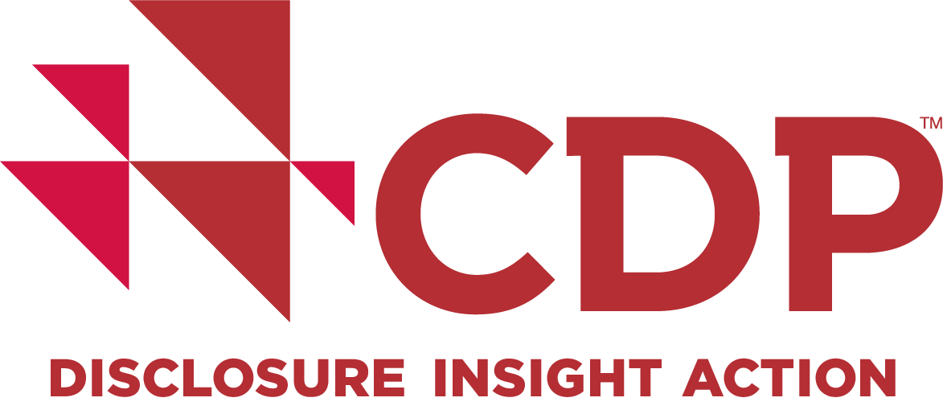

***EMBARGOED UNTIL 00:01 BST TUESDAY, OCTOBER 24 2017***
PICKING UP THE PACE:
ANALYSIS SHOWS CORPORATES RAISING THE BAR ON CLIMATE ACTION, AS 150+ COMPANIES TAKE THE TOP SPOT ON CDP’S ENVIRONMENTAL A LIST

- 89% of world’s biggest, most environmentally-impactful companies now have carbon emissions targets, with a fifth planning low-carbon into their futures to 2030 and beyond.
- 14% of 1,000+ sample are committed to aligning their targets with climate science, a 5% increase since last year. An additional 300+ companies (30%) plan to set science-based targets within two years.
- Companies are closing the emissions gap, with current targets taking the sample 31% of the way to a 2-degree world, up from 25% in 2016.
- The CDP A List names 159 leading corporates recognised as pioneers taking action on climate change, water and deforestation in 2017. Unilever and L'Oréal lead the way with A’s across all three areas.

October 24, 2017: The world’s largest annual tracker of how the largest, most environmentally-impactful companies are responding to climate change is published today by CDP (the non-profit global environmental disclosure platform). Picking up the pace, the second edition in the annual Tracking corporate action on climate change series, finds that more leading companies are embedding low-carbon goals into their long-term future business plans, and that they are increasingly aligning themselves with the carbon emission reductions scientists say are needed to prevent dangerous climate change.

Fourteen per cent of a sample of 1,073 responding companies have future-proofed their growth by committing to set science-based targets via the Science Based Targets initiative. These are emissions reduction targets in line with the level of decarbonization required to keep global temperature increase below 2 degrees Celsius, the central aim of the Paris Agreement on climate change signed by nearly 200 nations. An additional 317 companies (30% of the sample) aim to set science-based targets within two years. Existing targets take the sample almost one third (31%) of the way to being consistent with keeping global warming below 2 degrees, a notable improvement since last year (25%), reflecting the rise in science-based target-setting.
Key findings from today’s analysis include:
- More companies are mapping out their low-carbon future - 89% have emissions reductions targets this year (up from 85% in 2016); 68% have set emissions reductions targets to at least 2020 (up from 55%). 20% have longer-term targets to 2030 and beyond (up from 14%), crucial to avoid lock-in effects of current investments into high-carbon infrastructure and assets.

- Narrowing the emissions gap to meet global goals – achieving their current targets would take the companies in the sample 31% of the way to being consistent with keeping global warming below 2 degrees; a 6% improvement from the 25% reported in 2016.

- Growth in targets aligned with the latest climate science - 14% of companies in the sample have committed to the Science Based Targets initiative, an increase from 94 to 151 companies in the last year, including AkzoNobel, EDP and Unilever. An additional 30% – 317 companies – anticipate setting a science-based target within two years.

- Low carbon transition is driving innovation –
- Over a third (36%) of companies are offering low carbon products such as electric vehicles and zero-energy buildings (up from 30% in 2016).
- Three quarters (75%) of companies say their products and services enable third parties to reduce emissions, up from 64% in 2016.
- 32% of companies are now using internal carbon pricing, and a further 18% plan to implement this within two years.
- The number of companies with a renewable energy consumption target has increased by 23% in the last year, with companies including BT and Unilever committed to sourcing 100% renewable energy by 2030 as part of the RE100 initiative.
- The number of companies with a renewable energy production target has increased by 36% in the past year, from 55 to 75 companies.

- Climate is now a board-level topic - 98% of companies now have Board- or senior management-level responsibility for climate change, and 90% have financial incentives in place to attain corporate climate targets.

Paul Simpson, CEO of CDP, said: “Two years ago, the Paris Agreement fired the gun in the race to a low-carbon economy. This year, the recommendations from the Task Force on Climate-Related Financial Disclosures accelerated the pace. We can already see corporate winners and losers emerging. Best practice, from the scaling of solar power to the construction of zero-energy buildings, with innovation in processes, products and philosophies is emerging; and is increasingly led from the boardroom.

“That’s great news for those companies seizing the opportunity of the low-carbon economy, but the rest need to pick up the pace or risk losing out. The majority of the large corporations we analyzed do not yet appear to have the right, science-based targets in place to successfully transition their business in line with the Paris Agreement, although many have ambitions to take this step in the next two years. We strongly urge them to follow through and align their targets with climate science, to ensure their resilience in the transition to a well below 2-degree world.”
In a separate analysis, CDP ranked 159 companies (out of a total of over 3,300) as A-grade for their approaches to climate change, water and deforestation, working with scoring partners ADEC, CDP's Global Climate Change Scoring Partner, and South Pole Group, their partner for Water and Forests scoring, to assess companies’ performance. For the first time these three rankings are released simultaneously, reflecting the holistic nature of the environmental challenges facing business today.

- The 159 A List companies include: Colgate Palmolive Company, Diageo Plc., J Sainsbury Plc., Sky Plc. and Sony Corporation.

- Unilever and L'Oréal lead the way, both achieving A’s across all three areas of climate change, water and forests; demonstrating how business can reduce CO2 emissions, increase water security and tackle deforestation whilst making a profit.

- CDP's publicly released scores highlight increased corporate transparency and measurement of environmental action across the board, the number reporting to CDP rising 33% since 2013.

Graeme Pitkethly, CFO of Unilever says:
“Climate change is already affecting companies – both through the direct impacts of steadily rising global temperatures and through the policies that governments around the world adopt in response. At Unilever, we reduced CO2 from energy in manufacturing by almost two thirds over the past two decades and have set a bold target of being carbon positive by 2030, committed to sourcing 100% of our energy from renewable sources.

“Disclosure through the CDP platform is an important tool for Unilever to measure how we are performing against our sustainability plans and making progress to reduce our footprint. We are delighted to have been recognised as one of two companies to achieve straight ‘A’ scores across the rankings. Being a sustainable business goes hand-in-hand with being a successful business, as we drive profitable growth for our brands, save costs, reduce risk, and fuel innovation.”

CDP’s comprehensive 2017 analysis, Picking up the pace, assessed a sample of 1,829 companies, 1,073 of which responded to the request to disclose made on behalf of over 800 institutional investor signatories with assets of US$100 trillion. These responding sample companies represent 12% of total global greenhouse gas emissions. The sample was set in 2016 as a benchmark for corporate action on climate change and represents the most significant companies globally in terms of market capitalization and environmental impact.
Company examples named in the analysis include:

- AkzoNobel: The Dutch chemicals company will source 100% of energy from renewable sources by 2050 and introduced a carbon pricing policy including a ‘social cost of carbon’ of €135/tonne of CO2e.
- BT: The UK telecoms giant has set ambitious science-based targets to reduce its direct emissions by 87% by 2030.
- EDP: The Portuguese energy company produced some 65% of its electricity from renewable energy in 2016; by 2020, that figure is forecast to rise to 75%. It is projecting that its relative CO2 emissions will be 30% below 2015 levels by that date, on course to meet its 2030 science-based target.
- Nissan: The Japanese carmaker aims to be the leader in zero-emission vehicles. Since its launch in 2010, Nissan has sold more than 240,000 electric vehicles (EVs) around the world, becoming the number one provider of mainstream, mass market and affordable EVs.
- San Diego: The US city is working with GE Current, AT&T, Intel and others on its US$30 million Smart City initiative, which aims to improve the region's energy independence, to empower consumers to use EVs, to reduce greenhouse gas emissions, and to encourage economic growth.
- Unilever: A member of RE100, the Dutch-British consumer goods company is committed to sourcing 100% of total energy across its operations from renewables by 2030.
Steve Waygood, Aviva Investors’ Chief Responsible Investment Officer, said:
“As investors, the recommendations from the Task Force on Climate-Related Financial Disclosures have given us a very powerful mandate. The burden of proof to explain why climate risk isn’t an issue has shifted to companies. For those that recognize climate exposures, the new norm is that companies should be considering climate risk at the board level. The recommendations have created a new concept of climate risk governance. Disclosure of high-quality, comparable environmental data is at the heart of this concept.”

Picking up the pace: tracking progress on corporate climate action and the 2017 Climate, Water and Forests A Lists are available on the CDP website, which also includes rankings for thousands of companies that publicly disclose through CDP.

Ends

For more information, or exclusive interviews, please contact:
- Caroline Barraclough, ESG Communications tel : +44 (0)7503 771694 |
email: carolineb@esgcomms.com
or
- Elliot Frankal, ESG Communications tel : +44 7989 524780 |
email: elliot@esgcomms.com

About Picking up the pace: tracking progress on corporate climate action

The second in the annual Tracking progress on corporate climate action series, this analysis monitors corporate climate action using a baseline sample of 1,800+ companies selected in 2016 to represent the most significant in terms of market capitalization and environmental impact. Of these companies, 1,073 responded to CDP’s investor-backed disclosure request this year, and their progress on reducing greenhouse gas emissions in line with the goals of the Paris agreement is being tracked against the benchmark set in 2016.

As well as tracking companies’ progress on reducing emissions, CDP’s annual analysis monitors the adoption of targets based on the most up-to-date climate science (science-based targets), use of internal carbon pricing, and renewable energy production and consumption.

CDP is continuing to track the 700+ companies that have not yet responded to its disclosure request, to see if they begin to engage with this critical first step of climate action in future years.

About the CDP A List 2017

The CDP A List names the world's businesses leading on environmental performance, with 159 corporates recognized as pioneers in taking action on climate change, water and deforestation in 2017. Over 3,300 of the world's largest companies are scored from A to D-, highlighting increased corporate transparency and measurement of environmental action across the board in 2017; the number reporting to CDP rising 33% since 2013. Companies disclose to CDP at the request of over 800 investors with assets of US$100 trillion.

About CDP

CDP is an international non-profit that drives companies and governments to reduce their greenhouse gas emissions, safeguard water resources and protect forests. Voted number one climate research provider by investors and working with institutional investors with assets of US$100 trillion, we leverage investor and buyer power to motivate companies to disclose and manage their environmental impacts. Over 6,300 companies with some 55% of global market capitalization disclosed environmental data through CDP in 2017. This is in addition to the over 500 cities and 100 states and regions who disclosed, making CDP’s platform one of the richest sources of information globally on how companies and governments are driving environmental change. CDP, formerly Carbon Disclosure Project, is a founding member of the We Mean Business Coalition. Please visit www.cdp.net or follow us @CDP to find out more.

The Science Based Targets initiative is a collaboration between CDP, World Resources Institute (WRI), the World Wide Fund for Nature (WWF), and the United Nations Global Compact (UNGC) and one of the We Mean Business Coalition commitments. In total, over 300 companies have committed to set emissions reduction targets through the initiative.

